WhatsApp Channel Setup Guide for Chatwoot Copy
This guide walks you through setting up a WhatsApp Business channel in your self-hosted Chatwoot instance using Meta's WhatsApp Cloud API.

Table of Contents
- Prerequisites
- Part 1: Meta Business Platform Setup
- Part 2: Chatwoot WhatsApp Inbox Configuration
- Part 3: Testing the Integration
- Part 4: Going Live (Production)
- Part 5: Middleware Integration
- Troubleshooting
- Important Notes & Best Practices

MAIA communicates with your internal team through WhatsApp. To connect, you need a verified WhatsApp Business API account.
Estimated time: 1–2 hours of setup work + 3–7 business days for Meta verification. Can take longer if phone number KYC or Meta verification issues arise (see Important Warnings below).

Important Warnings — Read Before Starting
Phone number KYC (Malaysia): Company phone numbers in Malaysia require KYC registration with your telco provider. If you don't already have a suitable company number, getting one registered and activated can take 1–2 weeks. Start this immediately if you need a new number.

Meta account banning risk: Meta sometimes flags or bans new Business Manager accounts during setup — even when you've done nothing wrong. This is a known industry-wide issue. To reduce the risk:
- Do NOT create a new Meta Business Manager account if you already have one — use your existing one
- Do NOT attempt to register a phone number that is currently active on any WhatsApp app
- Follow the setup steps exactly — skipping steps or doing them out of order increases ban risk
- If you get banned or restricted, stop immediately and contact Mindhive before trying again. Repeated attempts after a ban make recovery harder

Prerequisites
Before starting, ensure you have:
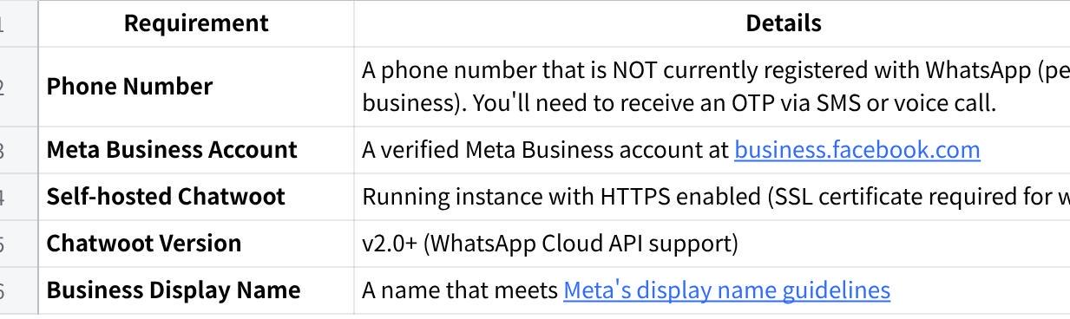
点击图片可查看完整电子表格

Phone Number Requirements
- Must be able to receive SMS or voice calls for verification
- Cannot be currently registered with WhatsApp (personal or WhatsApp Business app)
- If migrating from WhatsApp Business app, you must delete it first
- Recommended: Use a dedicated business line

Part 1 - Get a Dedicated Phone Number
You need a phone number that is:
- New or not currently registered on WhatsApp (personal or WhatsApp Business app)
- Able to receive SMS or voice calls (for verification)
- Dedicated to MAIA — it cannot be used for regular WhatsApp simultaneously
- Registered under your company name (KYC-compliant)

Options:
- Purchase a new prepaid SIM and complete KYC registration under your company
- Use a company landline number (Meta can verify via voice call)
- Port an existing number (only if it's not currently on WhatsApp)

Important: Once this number is registered with the WhatsApp Business API, it cannot be used with the regular WhatsApp app. This is a permanent change.

If you need a new number: Start the purchase and KYC process now. Do not wait for any other onboarding step. This is typically the longest wait in the entire setup.

Part 2: Meta Business Platform Setup

Step 2.1: Create or Access Meta Business Account
- Go to business.facebook.com
- Click Create Account (or log in if you have one)
- Enter your business details:
- Business name
- Your name
- Business email
- Complete the account setup

Step 2.2: Create a Meta App
- Go to Meta for Developers
- Click My Apps → Create App
- Select Other for use case, then click Next
- Select Business as the app type, then click Next
- Fill in app details:
- App name: Your app name (e.g., "MyCompany WhatsApp Bot")
- App contact email: Your email
- Business Account: Select your Meta Business Account
- Click Create App

Step 2.3: Add WhatsApp Product to Your App
- In your app dashboard, scroll to Add products to your app
- Find WhatsApp and click Set up
- You'll be redirected to WhatsApp Getting Started page

Step 2.4: Set Up WhatsApp Business Account
- On the WhatsApp Getting Started page, you'll see Step 1: Select phone numbers
- If you don't have a WhatsApp Business Account:
- Click Create a WhatsApp Business Account
- Select your Meta Business Account
- Enter business details
- If you have one, select it from the dropdown

Step 2.5: Add and Verify Your Phone Number
- In the WhatsApp dashboard, go to Step 1: Select phone numbers
- Click Add phone number
- Fill in the details:
- Display name: Your business name (must follow Meta's guidelines)
- Phone number: Enter your phone number with country code
- Verification method: Choose SMS or Voice call
- Click Next and enter the OTP received on your phone
- Your phone number is now registered
Note: The display name must accurately represent your business and follow Meta's naming guidelines. Misleading names will be rejected.

Step 2.6: Get Your API Credentials
After adding your phone number, collect these credentials:

Phone Number ID
- Go to WhatsApp → API Setup in the left sidebar
- Under Step 1: Select phone numbers, find Phone number ID
- Copy this value

WhatsApp Business Account ID
- Go to WhatsApp → API Setup
- Find WhatsApp Business Account ID in the same section
- Copy this value

Temporary Access Token (for testing)
- On the API Setup page, find Step 2: Send messages with the API
- Click Generate under Temporary access token
- Copy the token (valid for 24 hours)

Step 2.7: Generate Permanent Access Token
For production, create a permanent System User token:
- Go to Meta Business Settings
- Navigate to Users → System Users
- Click Add to create a new system user:
- Name: e.g., "WhatsApp API Bot"
- Role: Admin
- Click Create System User
- Click on the system user you created
- Click Add Assets:
- Select Apps
- Find your app and add it
- Grant Full Control
- Click Generate New Token:
- Select your app
- Set token expiration to Never
- Select these permissions:
- whatsapp_business_management
- whatsapp_business_messaging
- Click Generate Token
- Copy and save this token securely - you won't see it again!

Step 2.8: Configure Webhooks in Meta
Chatwoot will handle webhooks, but you need to know the URL format:
Plain Text
https://your-chatwoot-domain.com/webhooks/whatsapp/<inbox_id>

Note: You'll configure this after creating the Chatwoot inbox in Part 2.

Part 3: Chatwoot WhatsApp Inbox Configuration

Step 3.1: Navigate to Inbox Settings
- Log in to your Chatwoot instance
- Go to Settings (gear icon) → Inboxes
- Click Add Inbox

Step 3.2: Select WhatsApp Channel
- From the channel list, select WhatsApp
- Choose WhatsApp Cloud as the provider

Step 3.3: Enter API Credentials
Fill in the following fields:
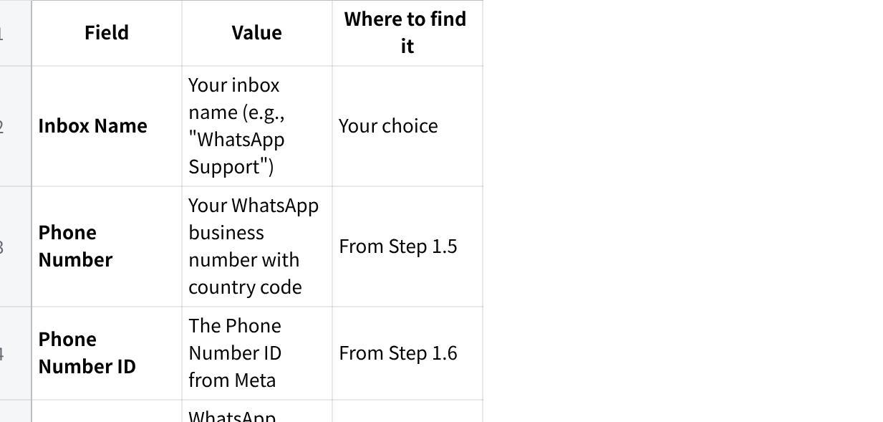
点击图片可查看完整电子表格

Step 3.4: Configure Webhook in Meta
After creating the inbox, Chatwoot will show you a webhook URL and verify token:
- Copy the Webhook URL from Chatwoot (format: https://your-chatwoot-domain.com/webhooks/whatsapp/<inbox_id>)
- Copy the Webhook Verify Token from Chatwoot
Now configure it in Meta:
- Go to your app in Meta for Developers
- Navigate to WhatsApp → Configuration in the left sidebar
- Under Webhook, click Edit
- Enter:
- Callback URL: Paste the Chatwoot webhook URL
- Verify Token: Paste the Chatwoot verify token
- Click Verify and Save

Step 3.5: Subscribe to Webhook Fields
After verification, subscribe to the required webhook fields:
- In the Webhook section, click Manage
- Subscribe to the messages field - this is required for receiving incoming messages

Step 3.6: Complete Inbox Setup
- Back in Chatwoot, complete the inbox setup
- Add agents to the inbox
- Configure business hours if needed

Part 4: Testing the Integration

Step 4.1: Add Test Phone Numbers (Development Mode)
While in development mode, only registered test numbers can message you:
- Go to WhatsApp → API Setup in Meta
- Scroll to Step 2: Send messages with the API
- Under To, click Manage phone number list
- Add your personal WhatsApp number as a recipient
- You'll receive a verification code on WhatsApp - enter it to confirm

Step 4.2: Send a Test Message
- Open WhatsApp on your personal phone
- Send a message to your business number
- Check your Chatwoot inbox - the message should appear

Step 4.3: Reply from Chatwoot
- In Chatwoot, click on the conversation
- Type a reply and send
- Verify it arrives on your WhatsApp

Step 4.4: Verify Webhook Delivery
If messages aren't appearing in Chatwoot:
- Go to WhatsApp → Configuration in Meta
- Check Webhook logs for delivery status
- Verify your Chatwoot server is accessible via HTTPS
- Check Chatwoot logs for errors

Part 5: Going Live (Production)

Step 4.1: Complete Business Verification
For production access, verify your business:
- Go to Meta Business Settings
- Navigate to Security Center
- Click Start Verification
- Submit required documents:
- Business registration certificate
- Utility bill or bank statement
- Articles of incorporation
- Wait for verification (typically 1-3 business days)

Step 4.2: Request Production Access
- In your app dashboard, go to App Review → Permissions and Features
- Request the following:
- whatsapp_business_management
- whatsapp_business_messaging
- Provide use case descriptions for each permission
- Submit for review

Step 4.3: Display Name Approval
Your display name must be approved for production:
- Go to WhatsApp → Overview
- Check the status of your display name
- If rejected, update it following Meta's guidelines

Step 4.4: Configure Message Templates
For initiating conversations or messaging after 24 hours:
- Go to WhatsApp → Message Templates
- Click Create Template
- Fill in:
- Name: Template identifier (lowercase, underscores)
- Category: Choose appropriate category
- Language: Select language(s)
- Body: Template content with variables like {{1}}, {{2}}
- Submit for approval (usually 24-48 hours)
Example template:
Plain Text
Hello {{1}}, thank you for contacting us!
Your inquiry #{{2}} has been received.
We'll respond within 24 hours.

Step 4.5: Go Live
Once approved:
- Your app automatically moves to live mode
- Remove test number restrictions
- Any WhatsApp user can now message your business

Part 6: Middleware Integration
This section covers integrating the WhatsApp/Chatwoot setup with the MAIA chatbot middleware.

Webhook Flow
Plain Text
User (WhatsApp) → Meta → Chatwoot → Middleware → AI Response → Chatwoot → Meta → User

Environment Variables
Configure these in your middleware .env file:
Bash
# Enable Chatwoot integration
CHATWOOT_ENABLED=True
# Your Chatwoot instance URL
CHATWOOT_API_URL=https://your-chatwoot-domain.com
# API tokens (from Chatwoot settings)
CHATWOOT_PLATFORM_API_TOKEN=your_platform_api_token
CHATWOOT_ACCOUNT_API_TOKEN=your_account_api_token
# Your Chatwoot account ID
CHATWOOT_DEFAULT_ACCOUNT_ID=1
# Message handling settings
CHATWOOT_MAX_MESSAGE_LENGTH=4000
CHATWOOT_ENABLE_MESSAGE_SPLITTING=True
CHATWOOT_MESSAGE_SPLIT_INDICATOR=[{current}/{total}]
CHATWOOT_MESSAGE_DELAY_MS=200

Chatwoot Webhook to Middleware
Configure Chatwoot to forward messages to your middleware:
- In Chatwoot, go to the WhatsApp inbox settings
- Add a webhook URL pointing to your middleware:
Plain Text
POST https://your-middleware-domain.com/api/v1/webhooks/chatwoot
For detailed integration instructions, see CHATWOOT_INTEGRATION.md.

Troubleshooting

Common Issues and Solutions

Webhook Verification Failed
Symptoms: Meta shows "Callback URL could not be verified"
Solutions:
- Verify your Chatwoot instance is accessible via HTTPS
- Check SSL certificate is valid and not self-signed
- Ensure the verify token matches exactly
- Check firewall/security rules allow Meta's IPs
- Verify the callback URL format is correct

Messages Not Appearing in Chatwoot
Symptoms: WhatsApp messages sent but not showing in Chatwoot
Solutions:
- Check webhook subscription includes messages field
- Verify webhook URL is correct in Meta settings
- Check Chatwoot logs for errors:
Bash
docker logs chatwoot-web -f
- Verify the inbox is active and has agents assigned

"Number is not registered" Error
Symptoms: Cannot add phone number to Meta
Solutions:
- Ensure the number isn't already on WhatsApp (personal or business)
- If migrating, delete WhatsApp Business app first
- Wait 24 hours after deleting before re-registering
- Try different verification method (SMS vs Voice)

Token Expired
Symptoms: API calls return authentication errors
Solutions:
- Regenerate temporary token (for testing)
- Create System User permanent token (for production)
- Update token in Chatwoot inbox settings

Message Delivery Failed
Symptoms: Replies from Chatwoot not reaching WhatsApp
Solutions:
- Check you're within 24-hour messaging window
- Verify API token has correct permissions
- Check rate limits haven't been exceeded
- For conversations older than 24h, use approved message templates

Display Name Rejected
Symptoms: Meta rejects your display name
Solutions:
- Use your official registered business name
- Avoid generic names like "Customer Support"
- Don't include promotional content
- Don't use WhatsApp-related terms
- Review Meta's naming guidelines

Checking Logs

Chatwoot Logs
Bash
# Self-hosted Docker
docker logs chatwoot-web -f
docker logs chatwoot-worker -f

Middleware Logs
Bash
# Check webhook processing
docker logs maia-api -f | grep -i chatwoot

Meta Webhook Logs
- Go to WhatsApp → Configuration
- View webhook delivery logs

Important Notes & Best Practices

24-Hour Messaging Window
WhatsApp enforces a 24-hour customer service window:
- Window Opens: When customer sends a message
- Window Closes: 24 hours after customer's last message
- During Window: You can send any message
- After Window: You can ONLY send approved template messages
Best Practices:
- Respond promptly to keep the window open
- Save template messages for follow-ups
- Track conversation timing

Message Templates
Required for:
- Initiating conversations (customer hasn't messaged you)
- Messaging after 24-hour window closes
- Notifications and alerts
Template Categories:
- UTILITY: Order updates, account alerts, receipts
- AUTHENTICATION: OTP, verification codes
- MARKETING: Promotions, offers (requires opt-in)

Rate Limits
WhatsApp Cloud API limits:
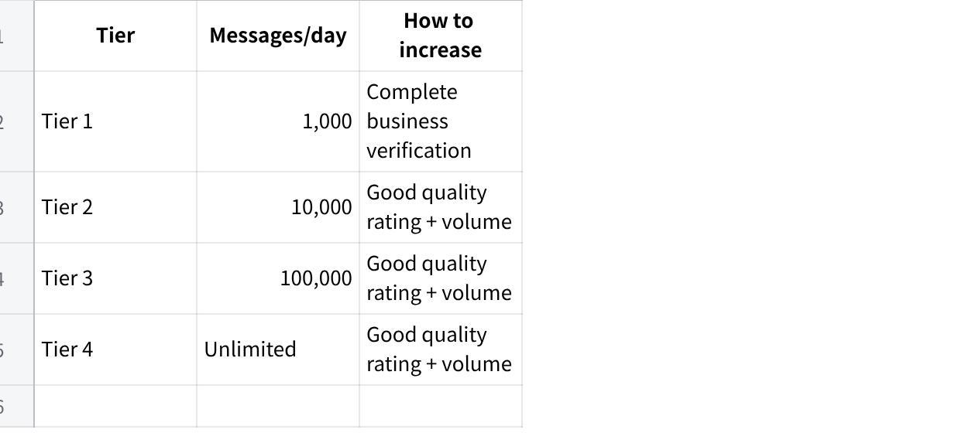
点击图片可查看完整电子表格

Quality Rating
Meta monitors:
- User blocks and reports
- Template message quality
- Response times
Keep quality high by:
- Only messaging opted-in users
- Responding within 24 hours
- Not sending spam or promotional content without consent

Phone Number Considerations
- Portability: You can migrate numbers between providers
- Multiple Numbers: Each number requires separate verification
- Display Name: Can be different from business name but must represent your business
- Country Codes: Always include country code (+1, +44, etc.)

Security Best Practices
- Token Security:
- Never commit tokens to version control
- Use environment variables
- Rotate tokens periodically
- Webhook Security:
- Always use HTTPS
- Validate webhook signatures if available
- Rate limit webhook endpoints
- Access Control:
- Limit who has access to Meta Business Suite
- Use appropriate system user permissions
- Audit access regularly

If You Get Stuck
This is common — Meta's interface changes frequently and their verification process is unpredictable. Contact your Mindhive product team contact and we will assist. In some cases, we may need to do this on-site with you.

Common blockers and what to do:
Problem | What to Do
Business verification rejected | Usually a documents issue — SSM cert, address proof, or company name mismatch. Contact Mindhive with the rejection reason.
Meta rejects your display name | Avoid generic names like "Customer Support"; don't include promotional content; don't use WhatsApp-related terms; review Meta's naming guidelines
Account banned or restricted | Stop immediately. Do NOT create a new account. Contact Mindhive — we have recovery procedures.
"Number is not registered" Error / Cannot add phone number to Meta | You need a different number, or delete the existing registration first (7-day wait period). Or you can try different verification method (SMS vs Voice)
KYC taking too long with telco | Follow up with your telco provider. If urgent, consider using a landline number instead.
Two-factor authentication issues | Contact Meta support directly, or let Mindhive handle it.

Quick Reference

Key URLs
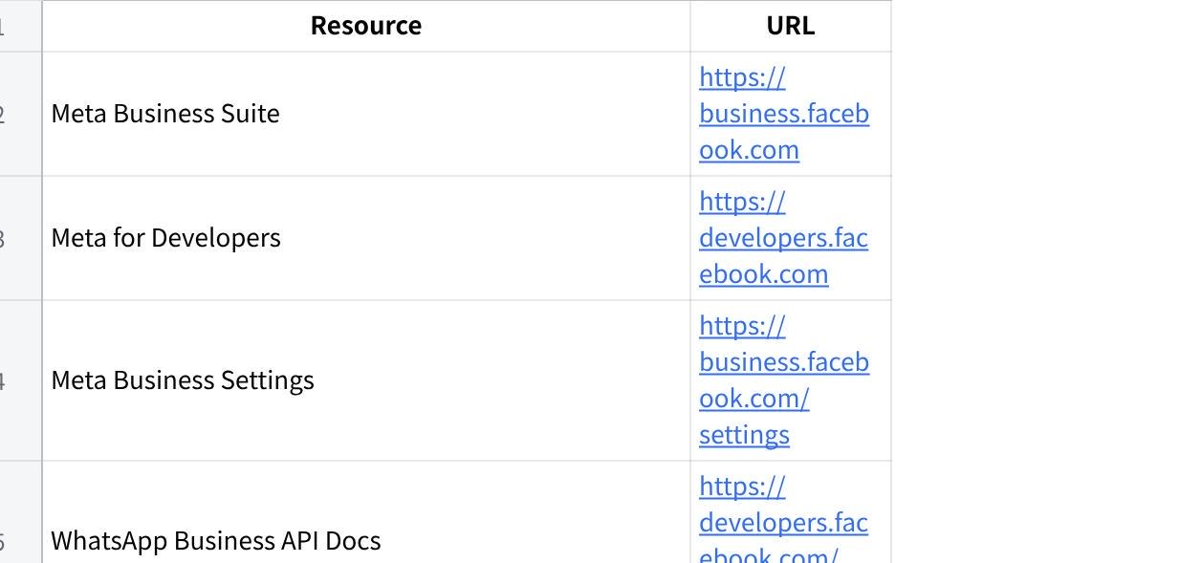
点击图片可查看完整电子表格

Required Credentials Summary
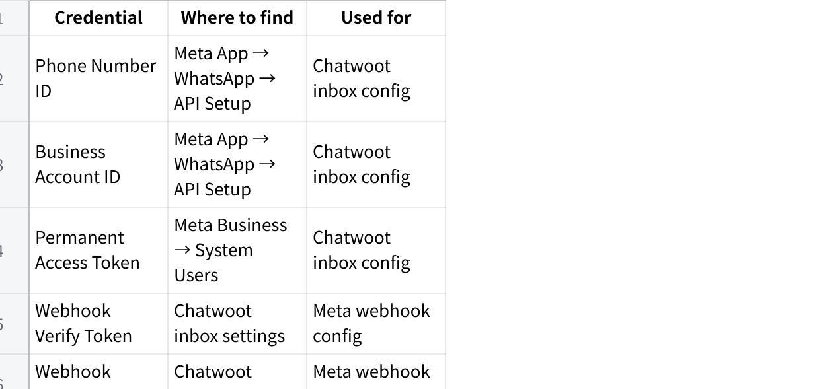
点击图片可查看完整电子表格

\Related Documentation
- Chatwoot Integration Guide - Middleware integration details
- Meta WhatsApp Cloud API Docs
- Chatwoot WhatsApp Docs

